FOCP ASSIGNMENT 1

MODULE 1
Ques 4
delayed time

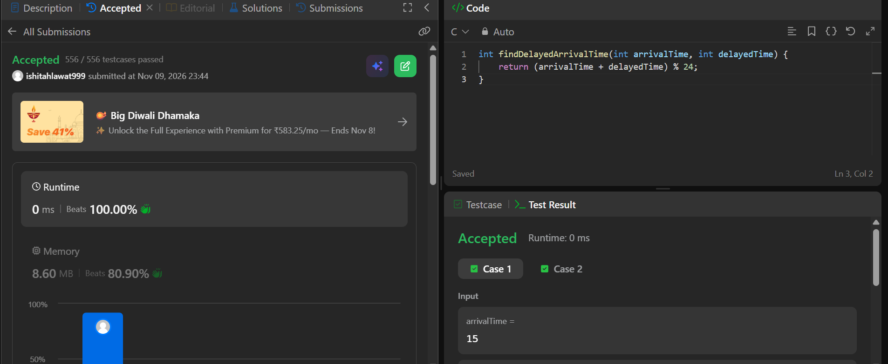

int findDelayedArrivalTime(int arrivalTime, int delayedTime) {
return (arrivalTime + delayedTime) % 24;
}

